

INDUSTRIAL NETWORKING

LAB
INTRODUCTION TO CISCO PACKET TRACER

Introduction
Cisco Packet Tracer is a network simulation tool made by Cisco Systems. It lets you build and test network setups on your computer with no physical equipment needed. It’s a great way to learn how networks work, especially if you're just getting started. You can use it to create everything from simple connections between two computers to large, complex networks with routers, switches, and more.
Learning Objectives
By the end of this lab, students will be able to:
- Open and navigate Cisco Packet Tracer
- Add and configure network devices
- Connect devices using appropriate cables
- Assign IP addresses and test connectivity (ping)
- Set up wireless networks
- Label and organize the topology
- Save and manage project files

Procedure
- Go to the Cisco NetAcad website: https://www.netacad.com. Register for a free account if you don’t have one. Once registered, navigate to https://www.netacad.com/resources/lab-downloads?courseLang=en-US and download then install Packet Tracer 8.2.2 Windows 64bit. The software is free to download.
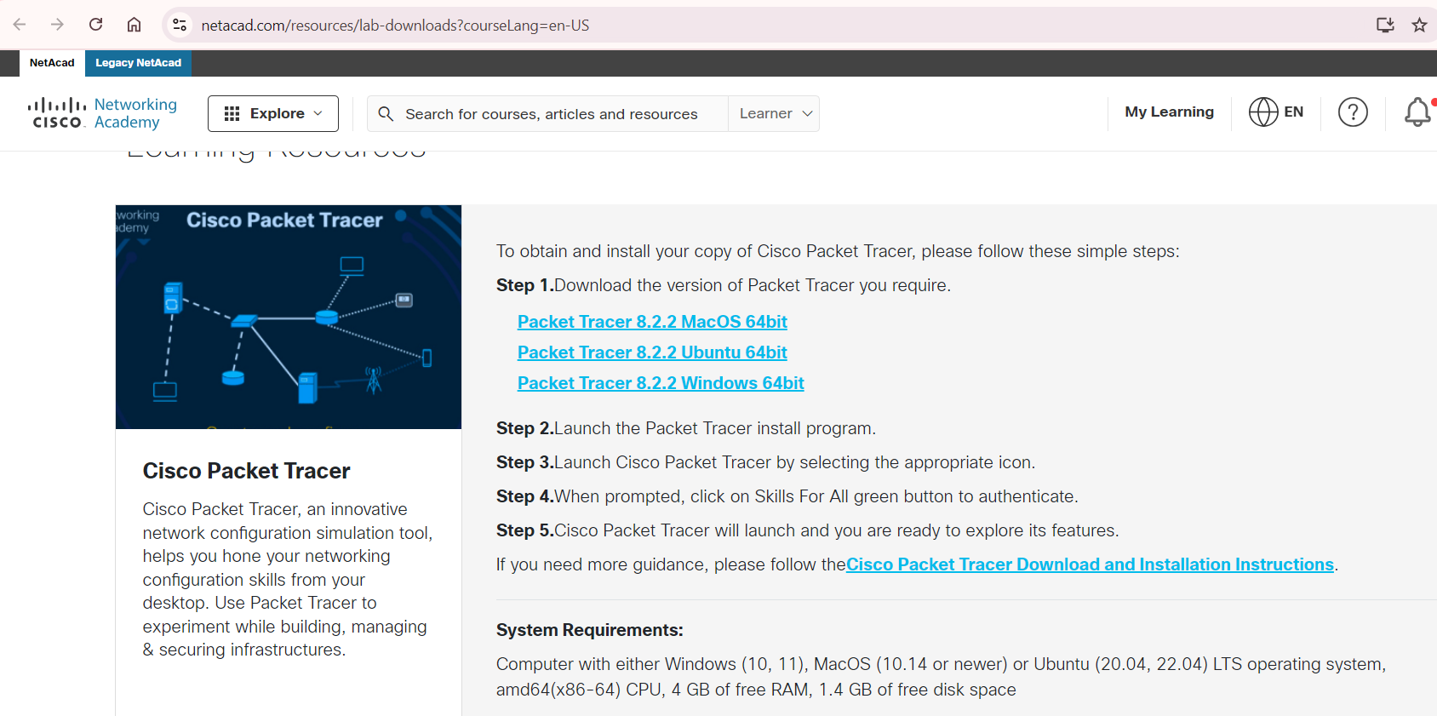

- After finishing the installation, launch Cisco Packet Tracer. You may need to log in with the account that you registered in step 1. When the software starts, its interface should look similar to the image below.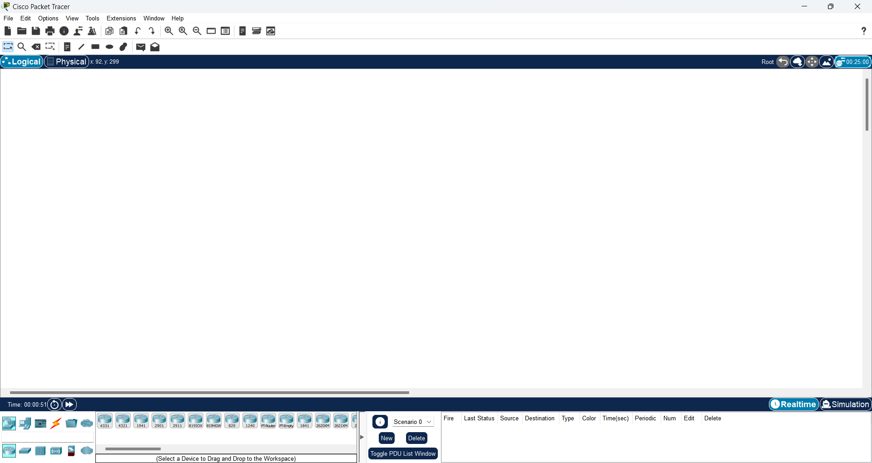

- Next, add a PC to the network.
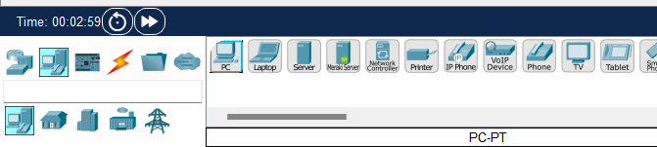
- Drag and drop the device with the desktop view into the workspace in the right section
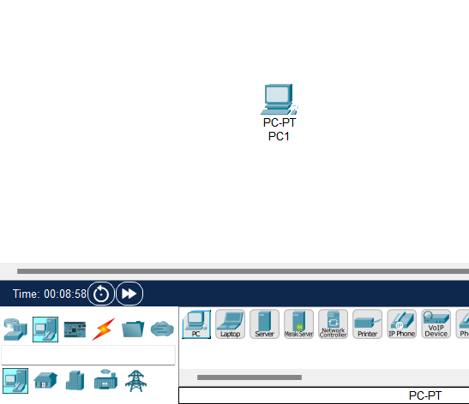
- After adding a PC, you can open the corresponding hardware settings window by double-clicking on the PC symbol.
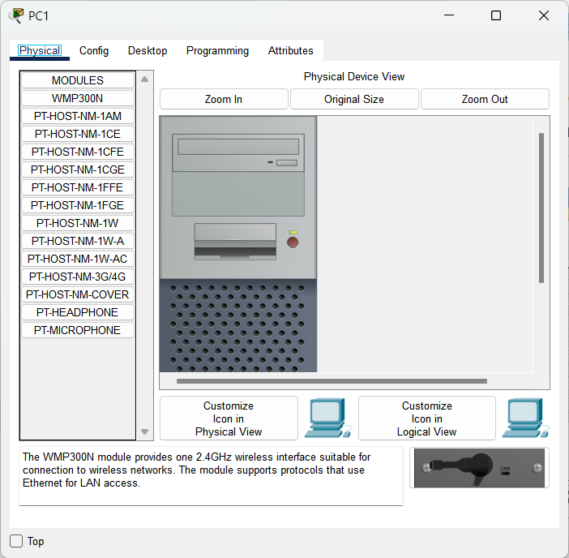
- To assign IP addresses, subnet masks, and default gateway addresses to the PC, go to Desktop tab, select IP Configuration
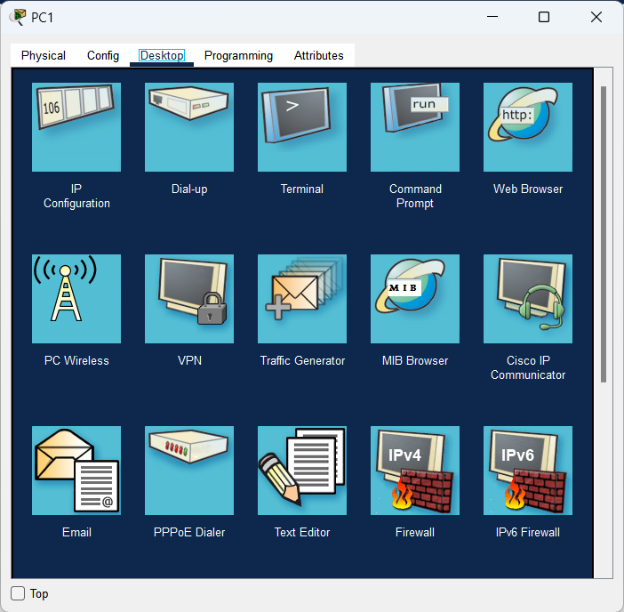
- Configure the IP address as below. Click on “X” to save and close this window.
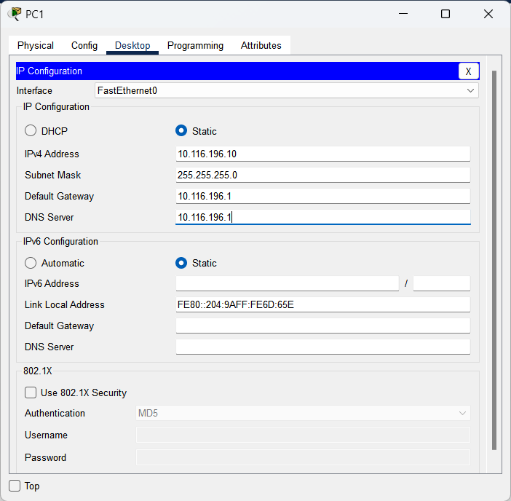
- Now, from Desktop, select Command Prompt, type command “ipconfig” into the Command Prompt, you can see the IP address settings of PC.
- The IPv4 address should match the one you set up earlier.
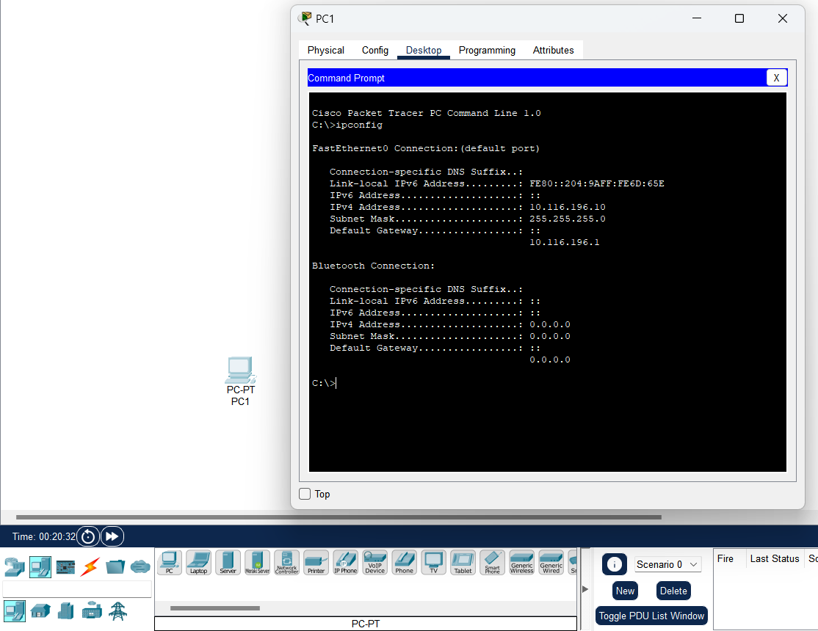
- To add a Cisco Switch to the workspace, click Network Devices and click Switches labelled 2960 from the options listed. 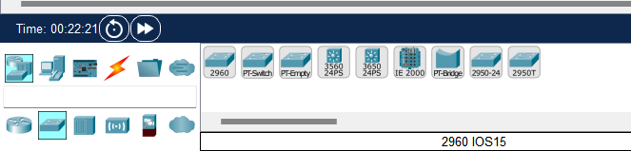
- Drag and drop the relevant Switch model from the workspace to your network.
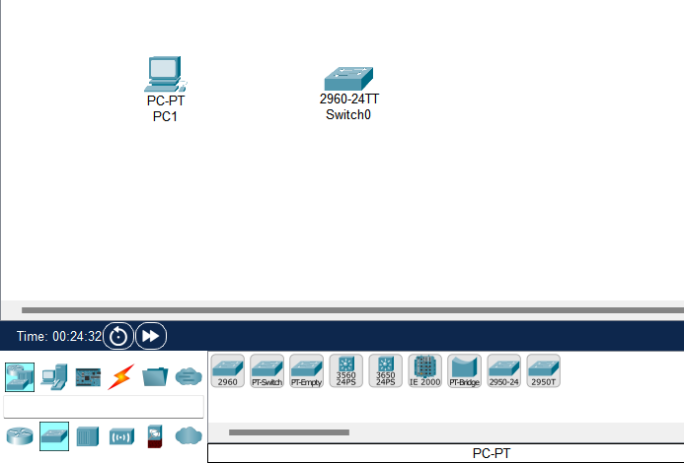
- Once you have added the switch to the workspace, click once to open its properties.
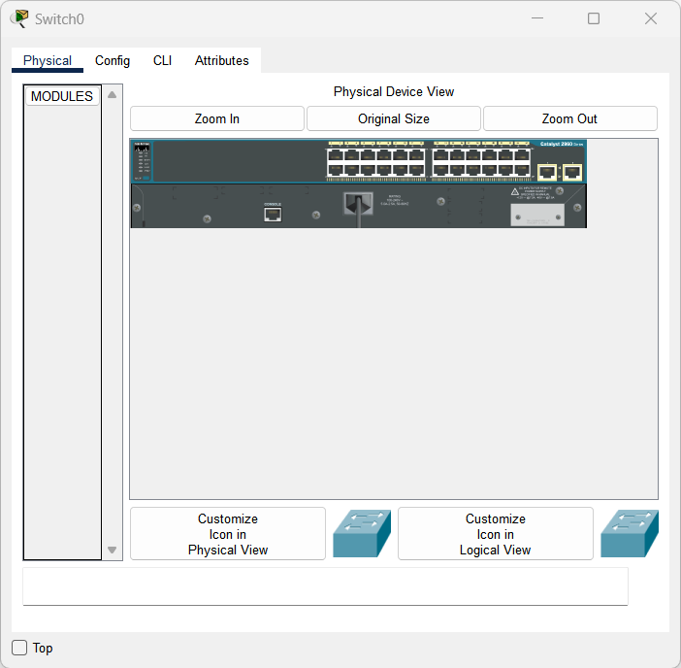
- Click the Config tab in the Switch0 properties window, you will see some settings related to the device. From here, you can change the name and hostname of the Switch in the workspace if you like.
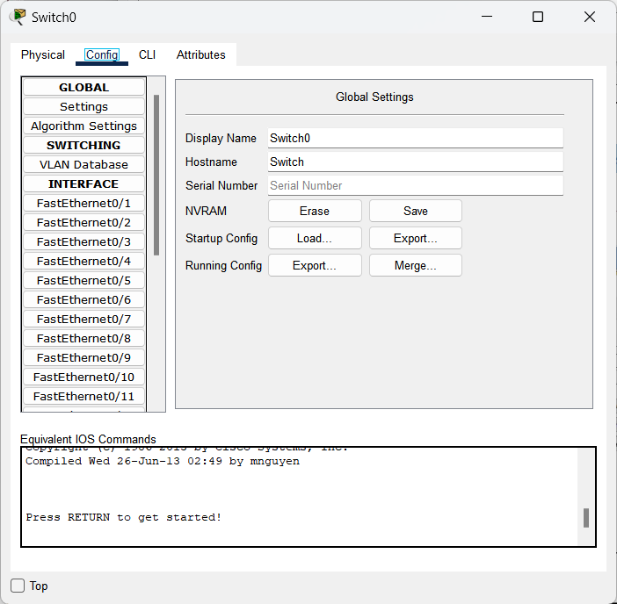
- After adding a PC and Switch to the workspace, you must connect these devices with a network cable. To cabling network devices in Packet Tracer, list the cable types that the program supports by clicking circled items as shown in the image below.
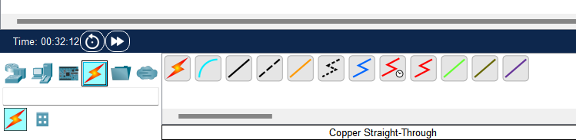
- From the network cable types, select the straight-through cable type and click PC0. Select FastEthernet0.
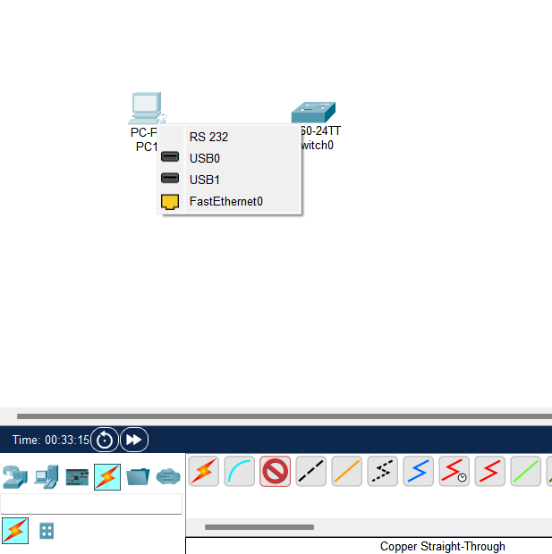
- Now click Switch0 to connect the PC to the Switch and select the first of the free ports listed.
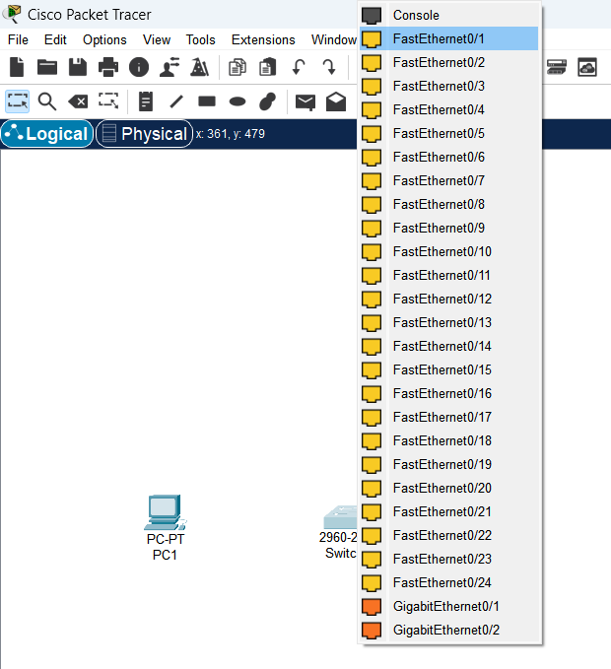
- After connecting the network cable, the port status color between the PC and the Switch will be orange at first but then will change to green after a few seconds, as in the following image. If the port is green, it means that the cable type is correct and working
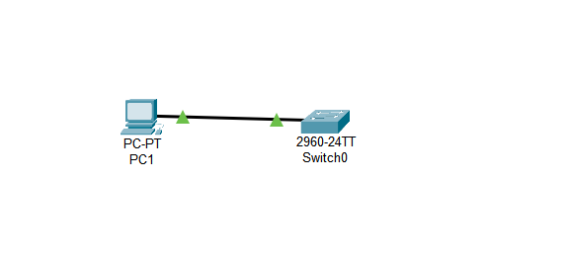
- Add one Laptop to the network topology and click the wiring option in the same way to connect it to the Switch. Set up the static IP Address as follows:
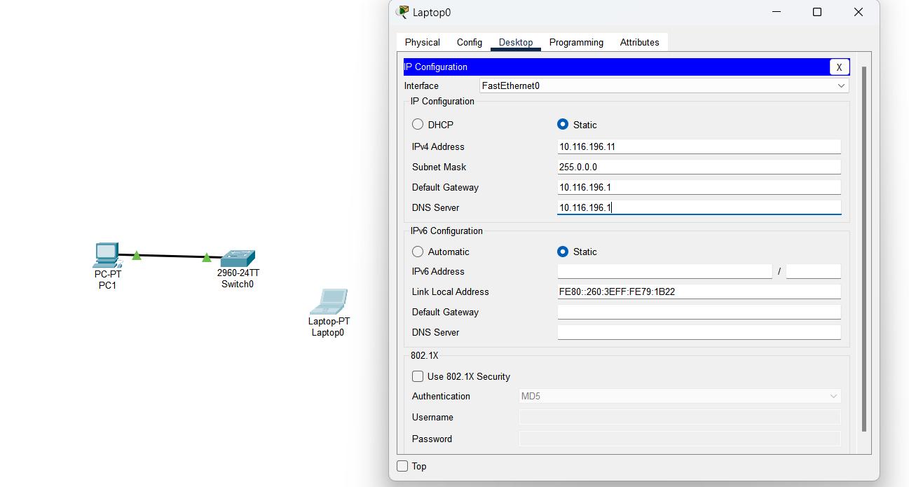

- The network after the previous step should look like the one below. Note that it may take a few seconds for the software to refresh the status of all devices connected to Switch 0. If you see the yellow color instead of green, make sure your static IP address is set correctly and wait for a few seconds.
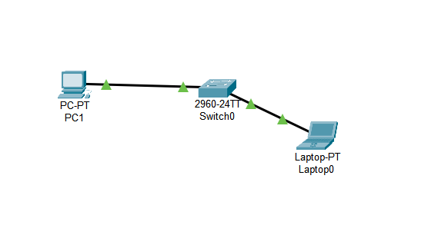
- To test connectivity among devices in this LAN, we can use the “ping” command. To use ping, open the properties of the client device and run the command prompt. Now, to ping from Laptop to PC, execute the ping 10.116.196.10 command on the CMD from the Laptop. Pinging from Laptop to PC will be successful as follows (0% packet loss).
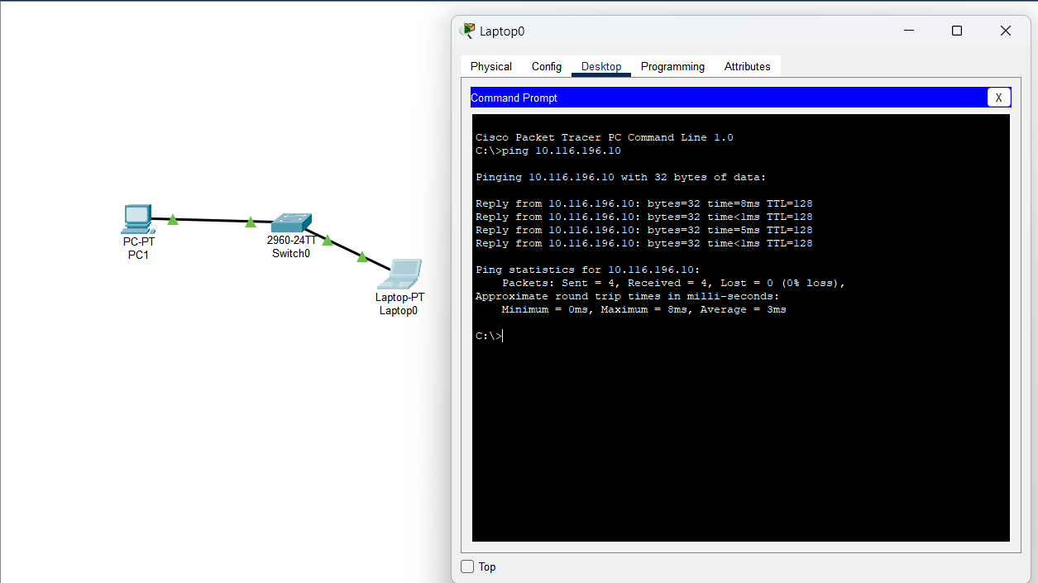

- When you ping from PC to Laptop, ping will also be successful.
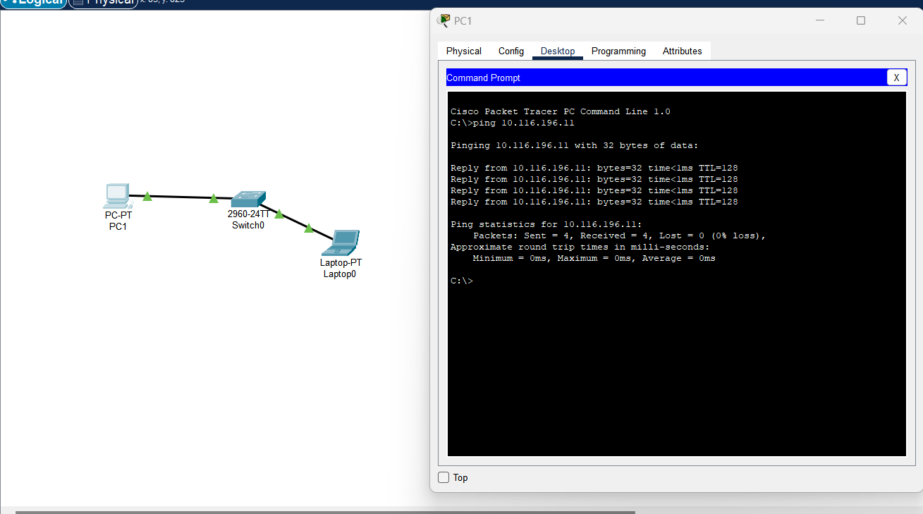
- You can also use Realtime to Ping in the PT. Real time is by default visible at the bottom right of the software.
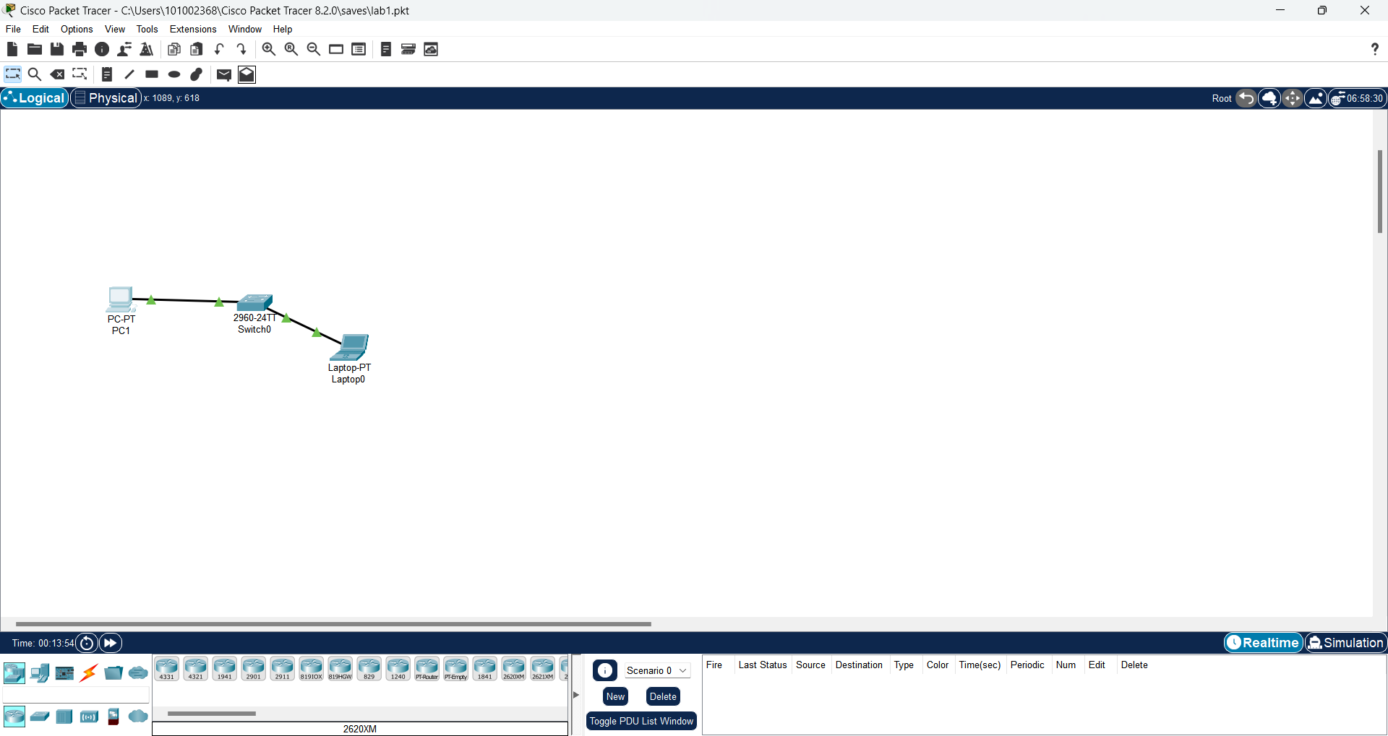
- On top left of the screen, select Add Simple PDU
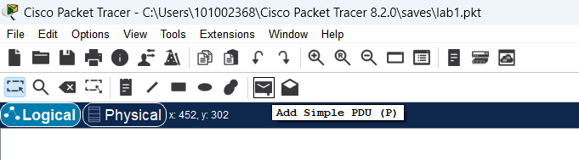
- After clicking ADD Simple PDU, you will see an envelope shape. Using this shape, you must select the source and destination client that you want to ping. Click the PC to set it as the source device, then click the Laptop to set it as the destination for the Ping operation.
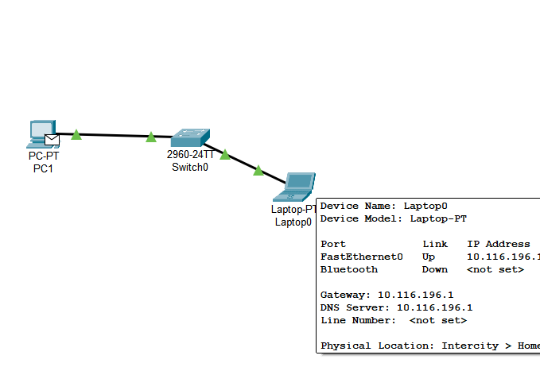
- As soon as you leave the envelope on Laptop0, you will see a message on the Realtime tab that Ping is successful.
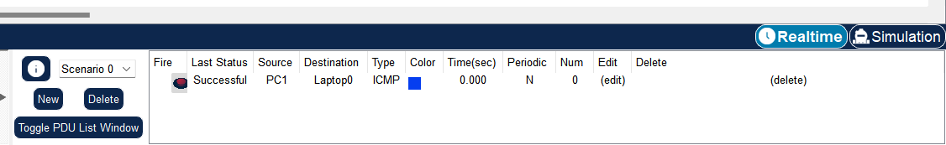
- In Packet Tracer, you must click Wireless Devices to add a Wireless Router to the workspace. From the listed wireless devices, click the Home Router wireless modem. When the Wireless Router is active, click the empty area to add it to the workspace:
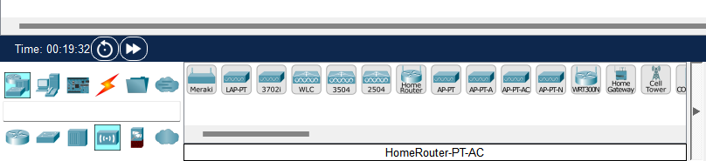
- Your workspace should look like the one below.
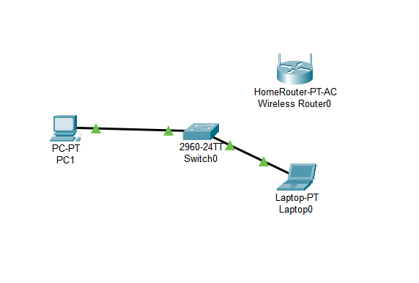
- Once the Home Router has been added to the workspace, to connect the wireless modem to Switch0: first click on the cabling tool at the bottom and then connect it to the GigabitEthernet1 then select Switch 0 and choose FastEthernet0/3.
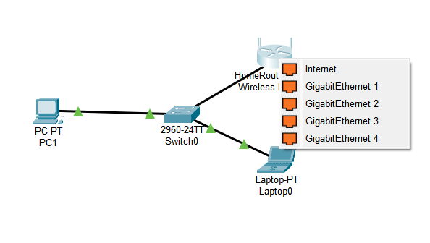
- Wait 30 seconds to have the yellow dots changed to green color.
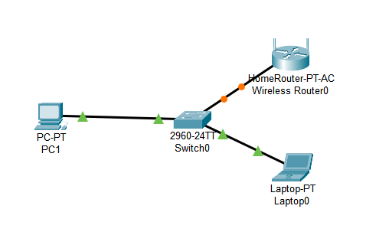
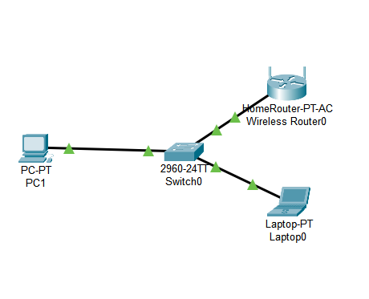
- After you have done wiring between the wireless modem and Switch0, click the GUI tab of the device’s properties.
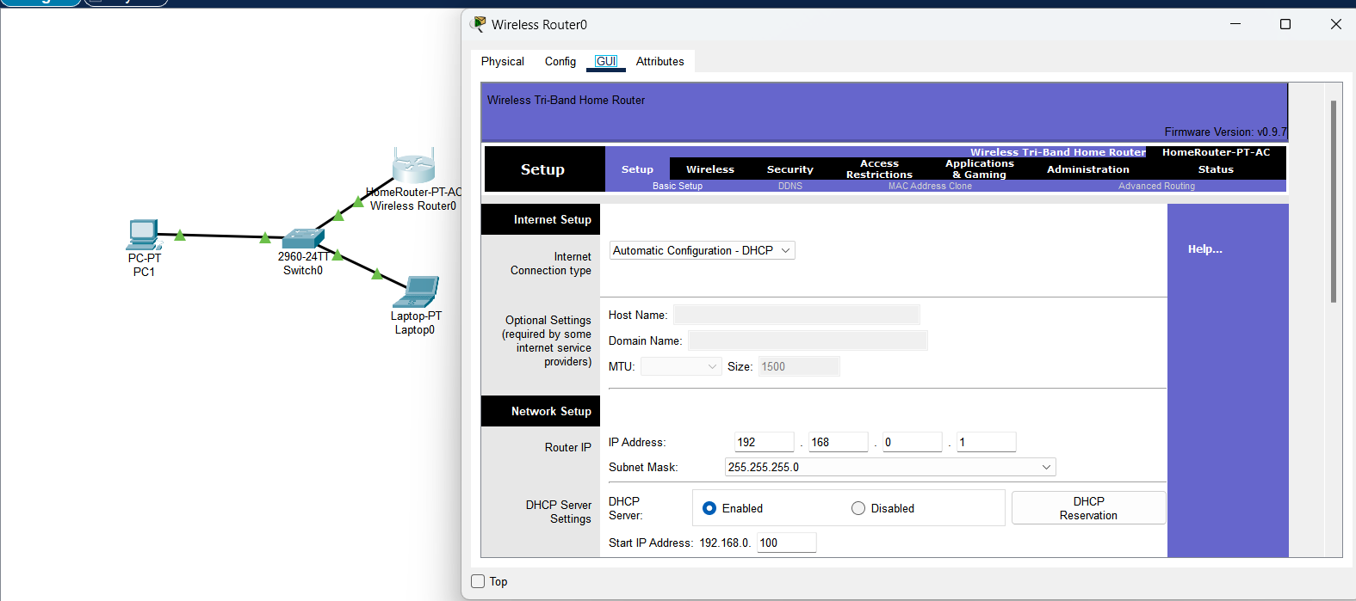
- To configure the LAN settings of the Wireless Router, enter the local network IP address 10.116.196.1 from the Network Setup option in the GUI interface and enable DHCP.
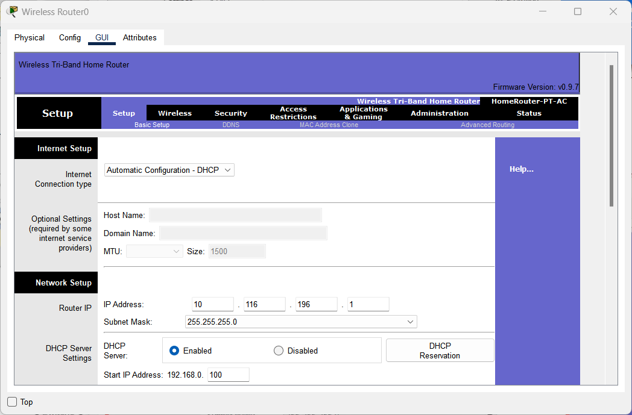
- Scroll down and click on Save settings then proceed to close this window.
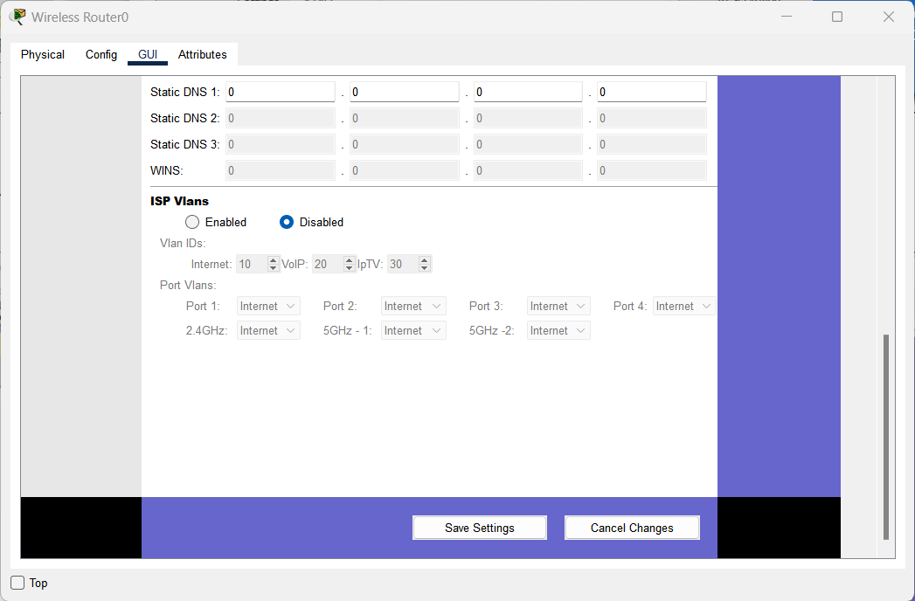
- Check that the connection is OK when you ping the wireless modem from PC:
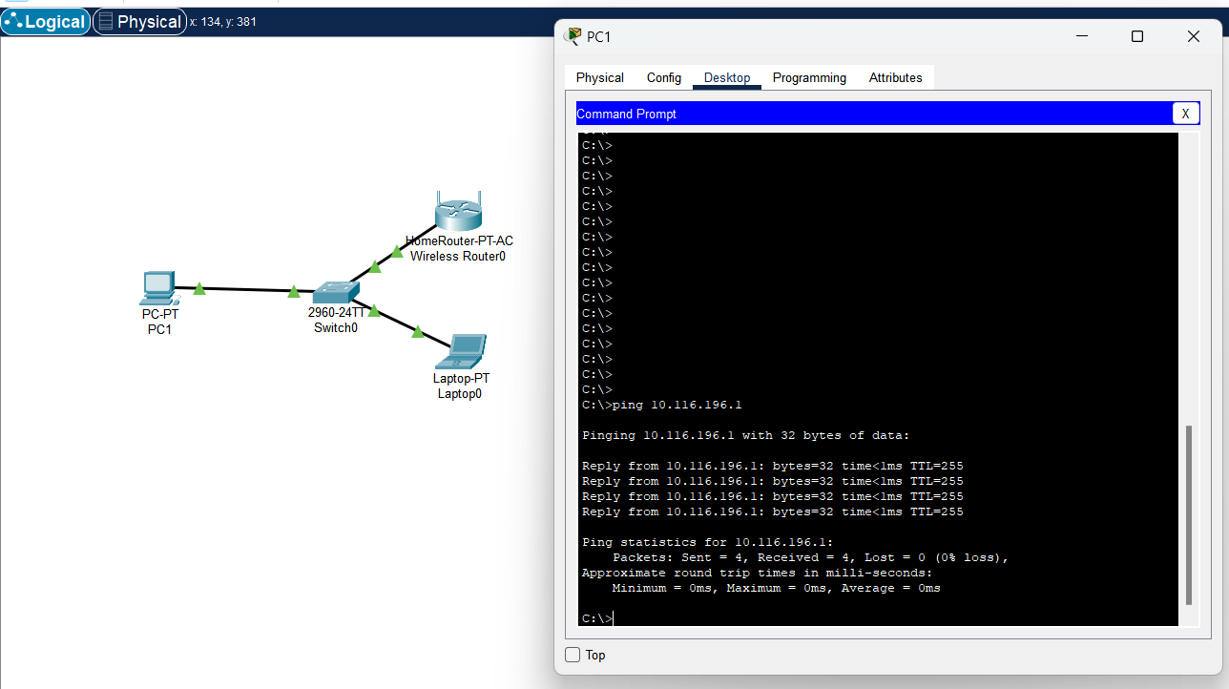

- To add a SmartPhone to the topology, follow the path shown in the illustration. After listing the devices, click the Smart Device Phone.
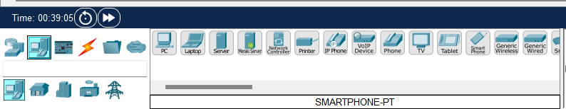
- After selecting the smartphone, click where you want to add it. As soon as the smartphone is added to the workspace, it will connect to the wireless modem. This is because the DHCP service is enabled on the wireless modem.
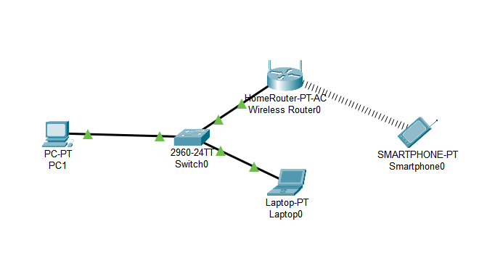
- Double click on the icon of smartphone then click on the Desktop tab of the smartphone properties. After clicking the IP configuration, you can see that the phone receives TCP/IP information from the DHCP server and has been leased an IP address.
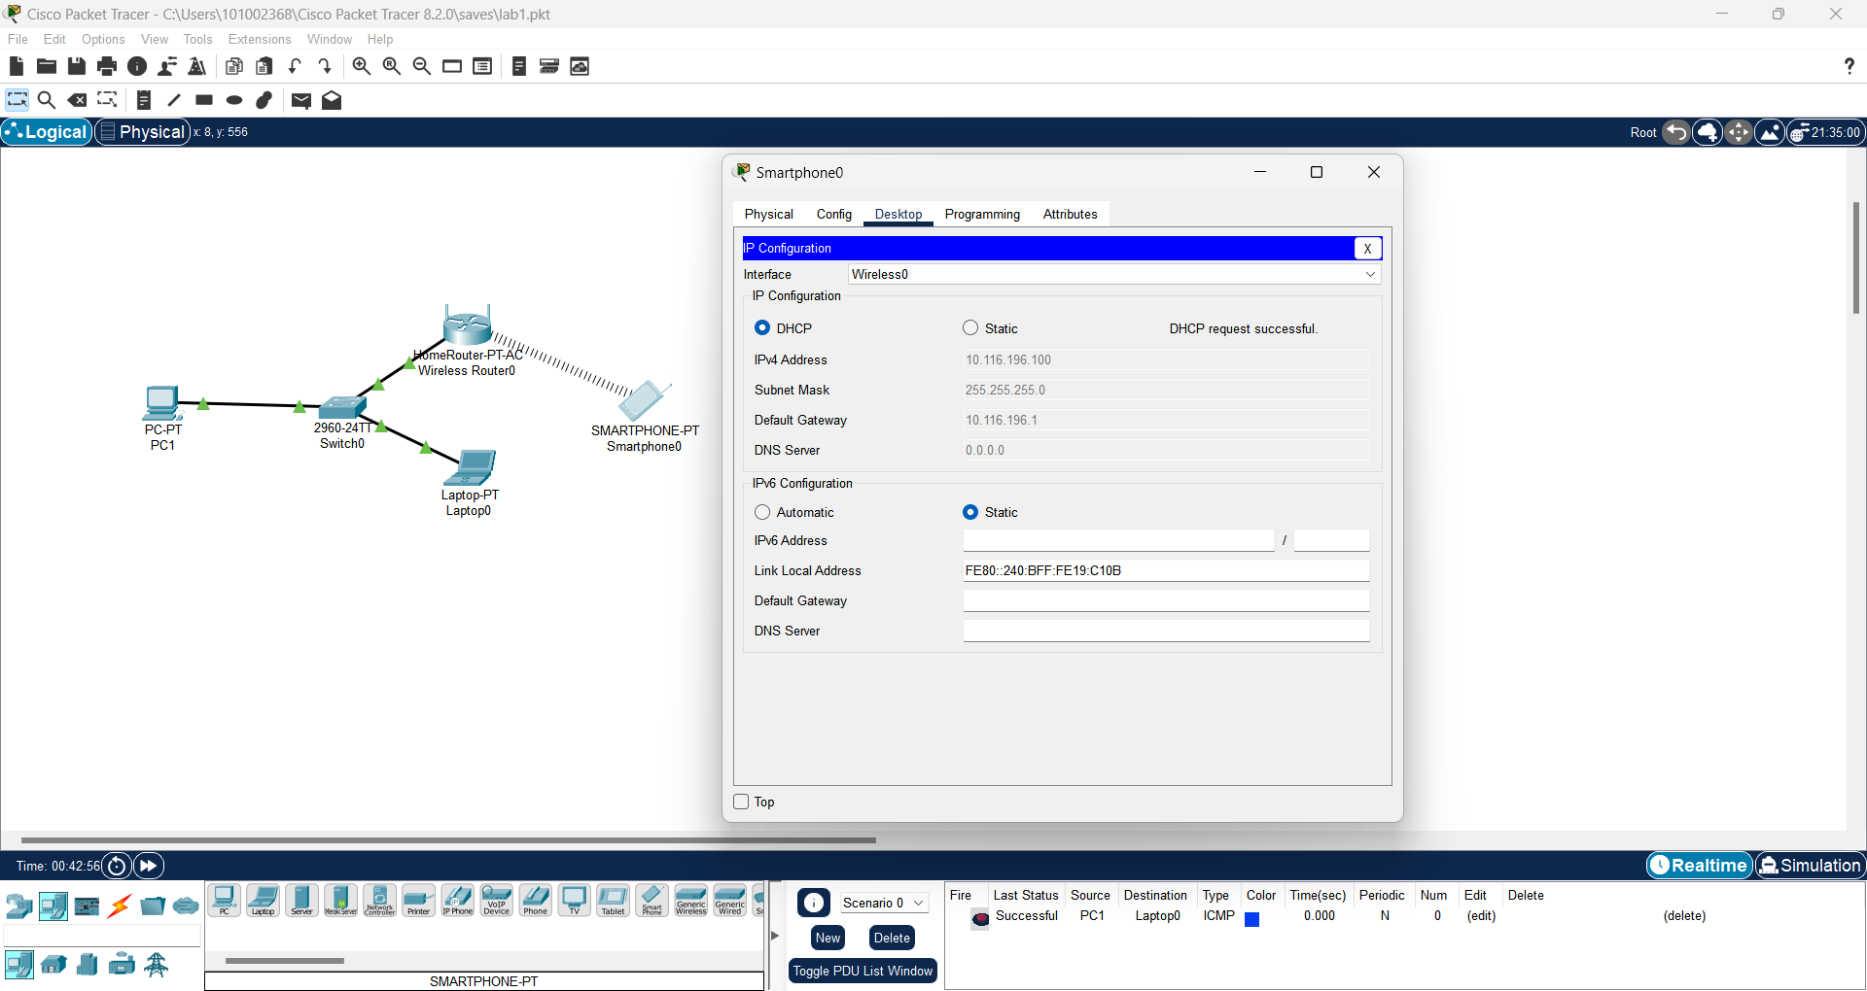
- Pinging from the smartphone to the wireless modem is successful:
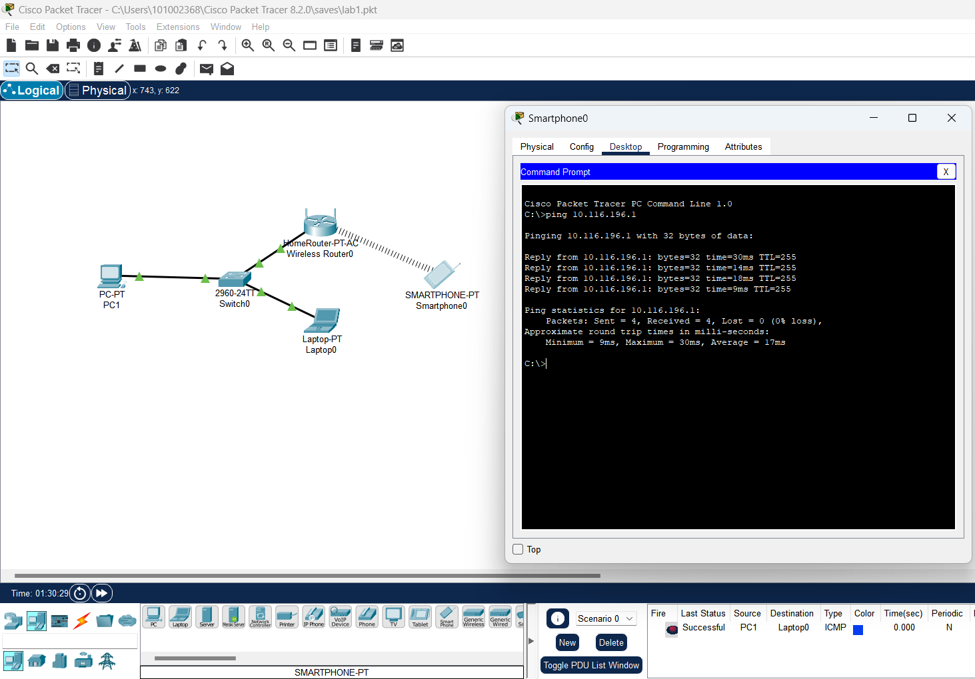
- When using the software, you can add comments/notes to the workspace to provide a more detailed network design. For example, you can note the IP address of each PC or specify the segments connected to the Router. To add a description, click (Place Note) as below and then click on the workspace.
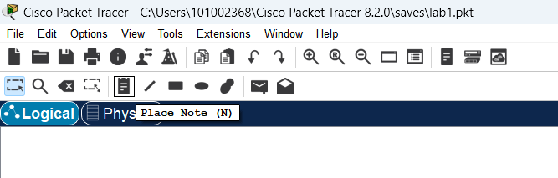
- After clicking the workspace, the text box will appear. You can add comments to network devices, as in the image below. After finishing your comments, hit escape to exit the comment box.
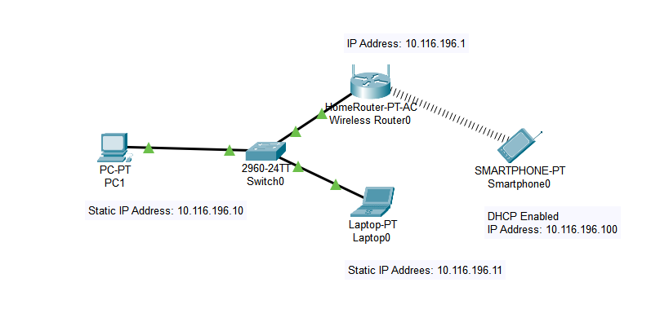
- You can add shape to make the topology more descriptive. First click on Draw Ellipse, after that a pop-up window will appear. In this window, select the shape you want to draw and then color the shape with the Color buttons.
No Fill: This option does not fill the color in the drawn shape.
Fill Color: This option applies the selected color to the shape
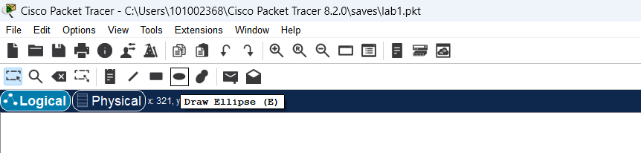
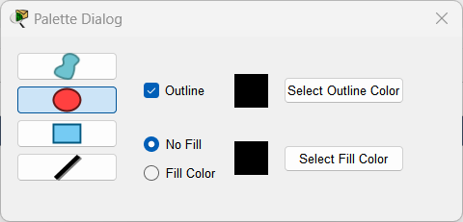
- For example, select a circle shape as in the image below:
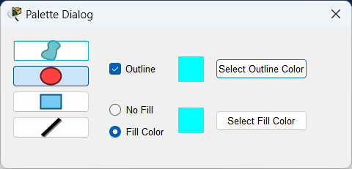
- Now, draw the shape on the workspace. Similarly for the rest.
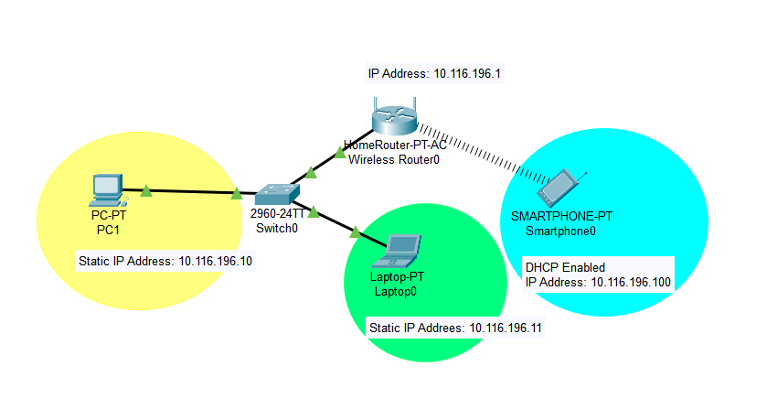
- Once you have created the shapes, you can use the Resize Shape feature on the right if you want to resize.
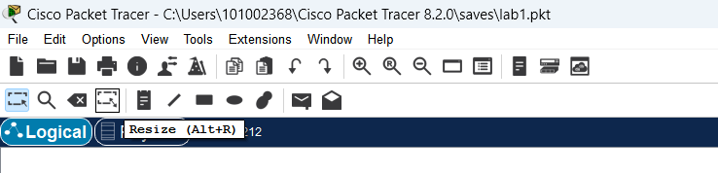
- After clicking Resize Shape, a red dot will appear on the edges of the shapes. You can resize shapes by holding down the red dots. After resizing the shapes, press the ESC key.
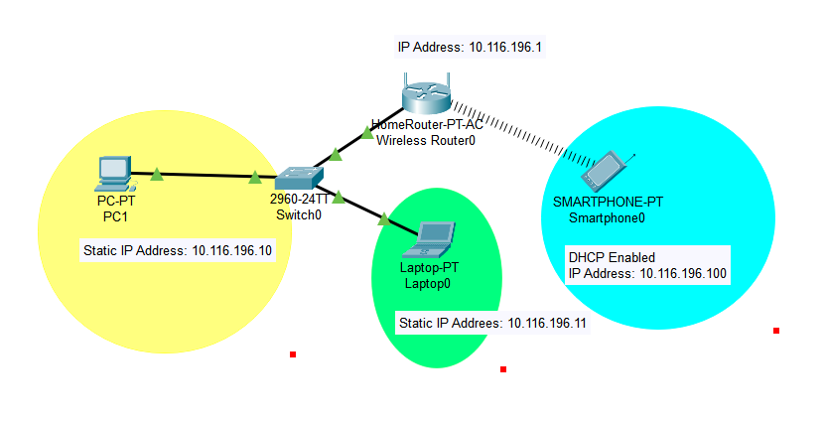
- Click on the X tool from the tools on the top to delete devices and shapes you added to your project.
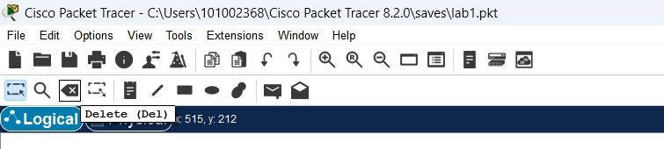
- This step is for illustration only. You do not need to follow. There will be a warning sign to confirm in case you want to delete an object.
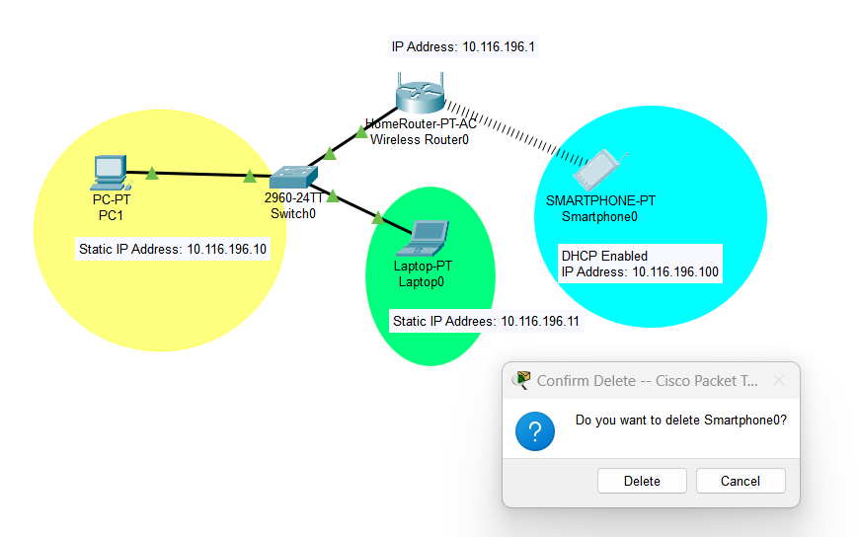
- If you click delete, the object will be deleted from the workspace.
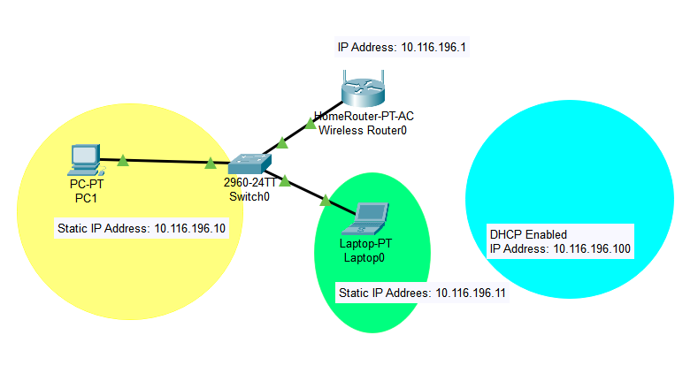
- To save your design, go to File, Save as then locate the directory where you want to save then click Save. The design file should have an extension of .pkt.
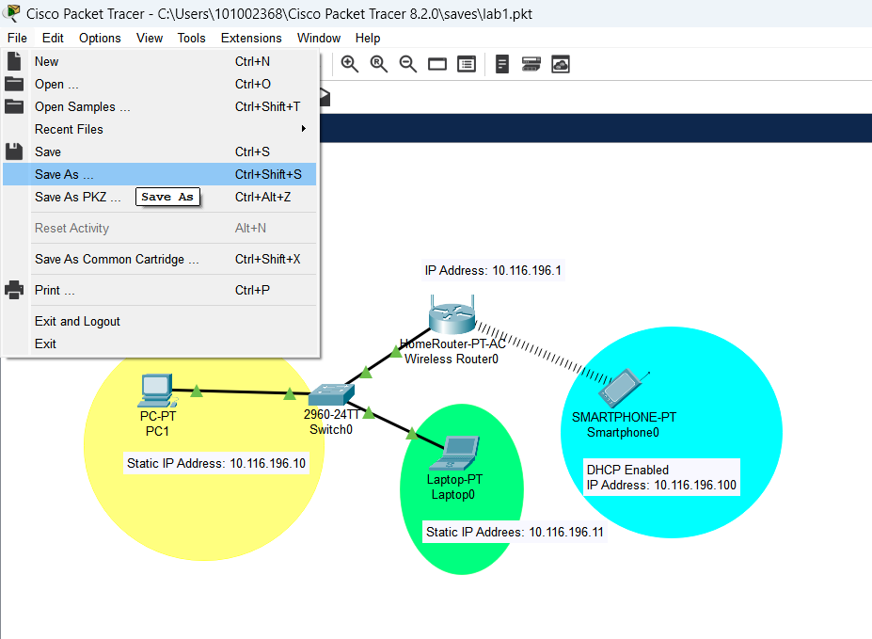

Practice
Scenario: Corporate Office Network with Static IPs and Interdepartment Communication.
Build a small network for a corporate office with two departments (HR and IT), a shared file server, and a network printer. Devices must be statically configured with predefined IPs and be able to communicate across departments.
Devices Required:
1 Router (Cisco 2911)
3 Switches (Cisco 2960)
6 PCs (3 for HR, 3 for IT)
1 File Server
1 Network Printer
IP Address Plan
Device | Department | IP Address | Subnet Mask | Default Gateway
PC0 (HR) | HR | 10.116.196.11 | 255.255.255.0 | 10.116.196.1
PC1 (HR) | HR | 10.116.196.12 | 255.255.255.0 | 10.116.196.1
PC2 (HR) | HR | 10.116.196.13 | 255.255.255.0 | 10.116.196.1
PC3 (IT) | IT | 10.116.197.11 | 255.255.255.0 | 10.116.197.1
PC4 (IT) | IT | 10.116.197.12 | 255.255.255.0 | 10.116.197.1
PC5 (IT) | IT | 10.116.197.13 | 255.255.255.0 | 10.116.197.1
File Server | Shared | 10.116.198.100 | 255.255.255.0 | 10.116.198.1
Network Printer | Shared | 10.116.198.200 | 255.255.255.0 | 10.116.198.1
Router Interface G0/0 | HR | 10.116.196.1 | 255.255.255.0 | -
Router Interface G0/1 | IT | 10.116.197.1 | 255.255.255.0 | -
Router Interface G0/2 | Shared | 10.116.198.1 | 255.255.255.0 | -

Requirements
Assign static IP addresses to all end devices using the above table.
Configure router interfaces (G0/0, G0/1, G0/2) with the correct IP addresses and make sure to enable them.
Use copper straight-through cables for:
PCs and servers to switches.
Switches to router interfaces.
Test connectivity:
HR PCs must ping IT PCs.
All PCs must ping the File Server and Printer.
Annotations and comments are required.
Desired Results
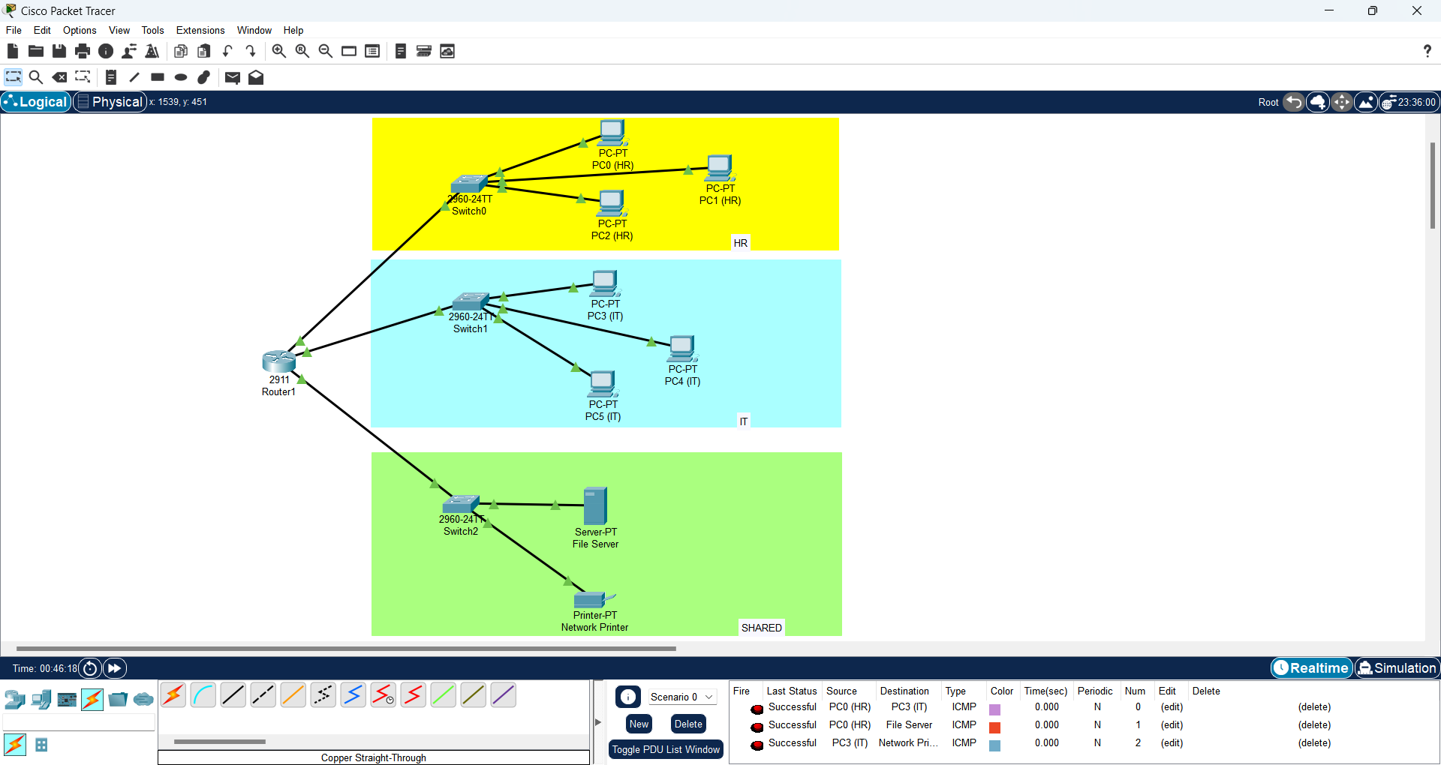
References
This lab was adapted in part from resources by Sysnettech Solutions (sysnettechsolutions.com)

